14TH MALAYSIAN ASSOCIATION OF VETERINARY PATHOLOGY (MAVP)
SCIENTIFIC CONFERENCE

22 – 24 SEPTEMBER 2023

MICROGRAPH AWARDS COMPETITION

Rules and Regulations:

- The competition is open to ALL participants of the 14th MAVP Conference 2023.

- Each participant may submit up to 3 images for judging.

- Photomicrographs must be taken using microscopes (all types of microscopes are allowable).

- Any type of specimen is acceptable. All microscopic techniques are acceptable.

- Image must be prepared in Microsoft PowerPoint slide and no personal information is allowed to be included in the picture.

- This information must be included in the slide image (bottom left):
  - Title (e.g., Sunflowers).
  - Sample type (e.g., Intestine, cat).
  - Brief description (e.g., The enteritis lesions observed in Infectious Bowel Disease [IBD] patient).
  - Magnification/Staining if applicable.

- The entries must be submitted latest by 8th September 2023 to confmavpreg@gmail.com

- All images will be exhibited during the conference and judging will be undertaken during the respected time.

- Entries will be judged on:
  - Originality
  - Image quality
  - Creativity
  - Information content

- Failure to accept all contest rules will disqualify the entry.

EXAMPLE ENTRY FOR THE BEST MICROGRAPH COMPETITION

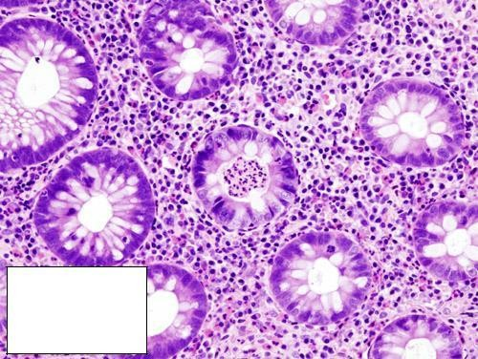
Title: Sunflowers
Sample type: Colon, human Description: The picture shows crypt abscess, which is classical in ulcerative colitis
Magnification: x400
Staining: H&E

*

